PRESS INFORMATION

Film presentation-
„A New We- ecovillages and eco-communities in Europe“

Directed by Stefan Wolf

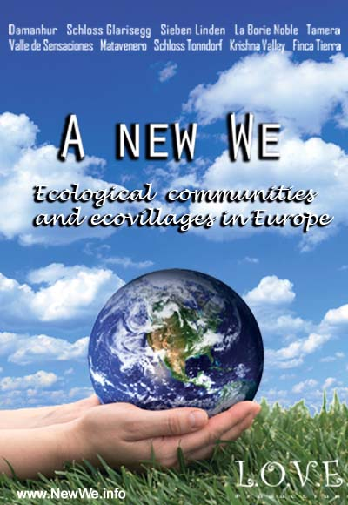

Infos, background, reviews, pictures

L.O.V.E. Productions
A project of Ökodorf GmbH

Augendobl 4
4751 Dorf an der Pram, Austria
Tel.: +43 676 974 8668
Email: office@newwe.info

www.NewWe.info

A New We – a documentary about ecovillages and eco-communities in Europe

About the film

The Austrian documentary filmmaker Stefan Wolf traveled through Europe in order to explore well established eco-communities and to present a broad spectrum of lifestyle possibilities to many people.

Experience two hours of insight into 10 European eco-communities from 8 European countries in this two hour long documentary portrait.

A New We is a unique and important film event that will lead you through the fascinating and varied worlds of these 10 communities: Sieben Linden, Damanhur, Tamera, Valle de Sensaciones, Matavenero, Schloss Glarisegg, Schloss Tonndorf, Krishna Valley, La Borie Noble, Finca Tierra.

How are these Communities organized?
What decision-making processes do they use?
How they finance themselves?
What food choices do they make?
How much of the food and energy that they need do they produce?
Is spirituality important?
How do adults and children interact?
Are there schools?

These and other questions are addressed in this unique and important film event.

The variety of situations and voices in A New We inspires hope for the future of humanity and all life on the planet. The lives shown here are more motivated by imagination, vision, respect and cooperation than by economic forces and social expectations. In these 10 communities, the creative solutions to many social, environmental and economic challenges exemplify the nearly infinite capacity for human-, community- and self-development. It’s a film that enlightens, encourages and spreads hope – for a new world and A New We.

It’s a film that enlightens, encourages and spreads hope – for a new world and A New We.

About the director

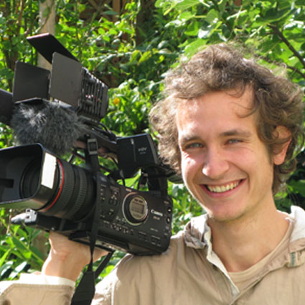

Stefan Wolf is born in Austria. He started to give his own healing-journey highest priority in his life after he got health problems in 2005. Since then he has constantly determined his life to the continuing process of healing in a holistic way: spiritually, mentally, emotionally and physically.

He has recognized that only by curing himself from past traumas, conditionings and patterns can he help to bring healing onto the whole existence on earth.

The fields of consciousness, potential of human beings, medicine and sustainable living in community are especially in his heart. Out of his studies about life and the roots of our collective illness, as well as through his personal community-living experiences, he saw the importance of creating self-sufficient communities and networks worldwide. Therefore he has created the documentary "A New We", which shall increase the awareness about the beauty and variety of natural and sustainable living in community.

In 2009 he has founded L.O.V.E. Productions which aims for the establishment of a whole new peace culture on earth.

His motto: "Follow your heart and your fortune will be certain!"

Presented communities

Damanhur
An Italian federation of eco-communities which altogether forms a network of about 1000 people. In Damanhur society's utopia is lived in daily reality.

Schloss Glarisegg
A community on the Bodensee in Switzerland, a seminar center for conscious being and living.

La Borie Noble
A community in France that lives according to the ideals of Mahatma Gandhi, living close to nature with strong spirituality and high self-sufficiency.

Finca Tierra
A tiny community in the Canary Islands that shows how beautiful, abundant and joyful a life close to nature can be.

Matavenero
Formerly an abandoned mountain village in Spain, Matavenero was rebuilt through the Rainbow movement. Today it's an autonomous commune with 70 permanent residents.

Krishna Valley
An ecovillage in Hungary with 150 residents, devoted to Krishna, with a very high level of self-sufficiency and a very small ecological footprint.

Schloss Tonndorf
A german ecovillage with 60 residents and a variety of lifestyles, an example of an ecological paradise, especially for children.

Das Valle de Sensaciones
A Spanish eco-community that encourages life-restoring experiences in nature and emphasizes luxury, abundance and beauty.

Sieben Linden
An ecovillage in Germany with 120 residents, a small ecological footprint, and creativity in design of its earth buildings.

Tamera
Tamera, the first Healing Biotope, is an international education and research center for the development of Peace Villages world-wide. Two hundred people live, work and study there in the south of Portugal.

Reviews

"Communities are trendsetters. This way of living is brought close to you vividly through this documentary. This film shows in an impressive and a touching way, that countless communities all around the world are already living „A New We“. Truly a strong message for a joyful, sutainable and healthy life on our planet – for the benefit of all beings!"
- Matthias Gerber, SPUREN: Swiss magazine, Nr. 96 in summer 2010

"Every once in a while, a film comes along that can transform the way we live. “A New We” by the Austrian filmmaker Stefan Wolf is such a film..“
- Will M. Tuttle, Ph.D., author, The World Peace Diet

"The film is a great enrichment!
Those two hours are worth every minute!"
- Dr. Ruediger Dahlke, German bestselling author, physician, psychotherapist

"This film is a fine introduction into the variety of ecovillages that can be found only in Europe..."
- Manitonquat (Medicine Story), spiritual leader, teacher and storyteller

“A New We” provides encouraging evidence that we can create sustainable societies of peace, creativity, and joy..."
- Madeleine W. Tuttle, artist and educator

Pictures and film extracts 

